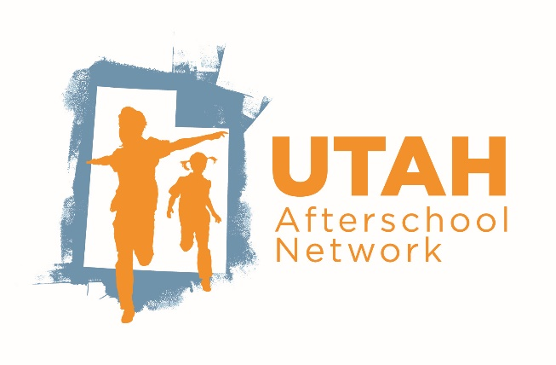

Program Action Plan

After completing the Quality Tool, review your responses, and identify areas of strength and areas of improvement. Select a goal in the Be Safe, Develop Meaningful Relationships, and Learn New Skills sections and create a SMART goal for each.

Organization
Program
Program ID #
First and Last Name of Submitter
Submitter’s Email Address

Be Safe Action Plan Form

Once you have identified a program goal for the Be Safe section, through your grant scopes of work, Quality Tool Self-Assessment, Program Observation, or survey, use this form to map out what steps you need to take to achieve them. We recommend that you utilize the Utah Education Policy Center’s Guidance On Creating SMART Outcomes worksheet to help establish strong goals.

The Goal I will work on:

I will know I achieved this when:

Steps to achieve this goal: | Resources and staff support needed: | By when:
Review Date:
☐ I have achieved this goal by meeting the criteria specified in the goal achievement statement(s) above. | ☐ I am making progress toward this goal and will keep implementing my action plan. | ☐ I need to make changes to my plan to achieve this goal by revising the goal or changing the action steps.
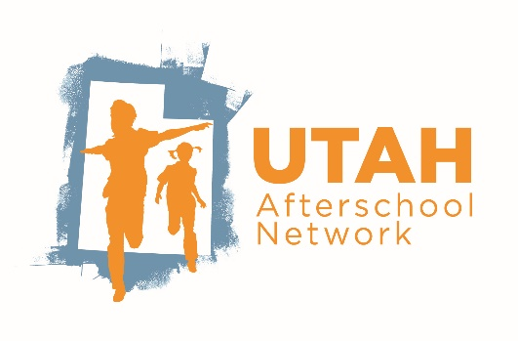

Develop Meaningful Relationships Quality Improvement Action Plan Form

Once you have identified a program goal for the Develop Meaningful Relationships section, through your grant scopes of work, Quality Tool Self-Assessment, Program Observation, or survey, use this form to map out what steps you need to take to achieve them. We recommend that you utilize the Utah Education Policy Center’s Guidance On Creating SMART Outcomes worksheet to help establish strong goals.
The Goal I will work on:

I will know I achieved this when:

Steps to achieve this goal: | Resources and staff support needed: | By when:
Review Date:
☐ I have achieved this goal by meeting the criteria specified in the goal achievement statement(s) above. | ☐ I am making progress toward this goal and will keep implementing my action plan. | ☐ I need to make changes to my plan to achieve this goal by revising the goal or changing the action steps.

Learn New Skills Quality Improvement Action Plan Form

Once you have identified a program goal for the Learn New Skills section, through your grant scopes of work, Quality Tool Self-Assessment, Program Observation, or survey, use this form to map out what steps you need to take to achieve them. We recommend that you utilize the Utah Education Policy Center’s Guidance On Creating SMART Outcomes worksheet to help establish strong goals.
The Goal I will work on:

I will know I achieved this when:

Steps to achieve this goal: | Resources and staff support needed: | By when:
Review Date:
☐ I have achieved this goal by meeting the criteria specified in the goal achievement statement(s) above. | ☐ I am making progress toward this goal and will keep implementing my action plan. | ☐ I need to make changes to my plan to achieve this goal by revising the goal or changing the action steps.

